A Beginner's Study of Identifying an Unknown DNA Sequence Using BLAST
(Record of Practicals and AI Chat Logs)
Name: MIDHUN BALAJI | Reg. No: 25010115020 | Course: Programming with Generative AI

AI tool used: Gemini, NotebookLM, Perplexity

Prompt 1 – Broad Overview
Prompt:
What is DNA sequencing and why is identifying unknown DNA sequences important in computational biology?
AI reply (summary):
Explained that DNA sequencing determines the order of A, T, C, G bases. Emphasized that matching unknown sequences to reference databases (like GenBank) lets us identify species, detect pathogens, and study evolution.

Prompt 2 – BLAST Concepts
Prompt:
What is BLAST and how does it search local alignments in biological sequences?
AI reply (summary):
Described BLAST as a seed-and-extend algorithm that finds high-scoring local alignments between a query and database sequences, then computes statistical significance (E-value).

Prompt 3 – FASTA Formatting
Prompt:
How are query DNA sequences formatted in FASTA format for BLAST?
AI reply (summary):
Showed FASTA format: a header line starting with > followed by sequence lines of A/T/C/G. Gave a 70 bp example.

Prompt 4 – Application Selection
Prompt:
What real-world application should I select for identifying unknown bacterial species?
AI reply (summary):
Compared clinical diagnostics, food fraud, and environmental DNA; recommended clinical pathogen identification because of direct patient impact and clear use of 16S rRNA + BLAST.

Prompt 5 – Sub-Problem Breakdown
Prompt:
How can I break down my topic into 5 candidate sub-problems according to Course Step 4?
AI reply (summary):
Produced five sub-problems: (1) which BLAST metrics matter, (2) effect of query length, (3) effect of mutations, (4) effect of database size, (5) automating decisions with thresholds.
Prompt 6 – Clinical Impact
Prompt:
How does rapid bacterial identification using BLAST save patient lives in hospital settings?
AI reply (summary):
Explained that 16S rRNA sequencing + BLAST can identify sepsis-causing bacteria in hours instead of 2–3 days for culture, enabling faster, targeted antibiotics.

Prompt 7 – Metric Definitions
Prompt:
What specific metrics does BLAST output to prove match accuracy?
AI reply (summary):
Defined Percent Identity, Query Coverage, and E-value, and explained how each reflects match quality and chance.

Prompt 8 – Refined Sub-Problem
Prompt:
State the refined sub-problem statement in 1–2 sentences.
AI reply (summary):
Produced:
“How do BLAST alignment metrics—specifically E-value, Percent Identity, and Query Coverage—differentiate an exact species match from random background alignment when identifying an unknown bacterial DNA sequence?”

Prompt 9 – Scoring Matrix Mechanics
Prompt:
How does BLAST calculate raw alignment scores for match, mismatch, and indels?
AI reply (summary):
Explained match reward (+1), mismatch penalty (−2), gap open (−5), gap extend (−2) as typical nucleotide scoring, and how these sum to a raw score S.

Prompt 10 – Karlin–Altschul Equation
Prompt:
What is the mathematical equation for E-value calculation in BLAST?
AI reply (summary):
Gave:
E = K · m · n · e^(−λS)
where m = query length, n = database size, S = raw score, and K, \lambda are statistical parameters.

Prompt 11 – 16S rRNA Target
Prompt:
Why is the 16S rRNA gene specifically targeted for identifying unknown bacteria?
AI reply (summary):
Explained conserved regions for universal primers and hypervariable regions (V1–V9) that distinguish species; noted widespread use in clinical and environmental microbiology.

Prompt 12 – Local vs Global Alignment
Prompt:
Why is local alignment (BLAST) preferred over global alignment (Needleman–Wunsch) for short DNA queries?
AI reply (summary):
Clarified that short reads usually match only part of a long reference genome; local alignment finds the best matching region without forcing end-to-end alignment.

Prompt 13 – Practical Code Setup
Prompt:
Write a Python script using Biopython Pairwise Aligner to compare an unknown query against a 5-species bacterial database.

Code 1 – Basic 5-species local alignment

python
from Bio import Align

# Unknown query (70 bp, 16S-like fragment)
query_seq = (
"AGAGTTTGATCCTGGCTCAGGATGAACGCTGGCGGCGTGCCTAATACATGCAAGTCGAACG"
"GTAAC" # trimmed to 70 total if needed; adjust as you like
)
query_seq = query_seq[:70]

# 5-species “database” (short representative 16S fragments)
db = {
"Escherichia_coli_K12": (
"AGAGTTTGATCCTGGCTCAGGATGAACGCTGGCGGCGTGCCTAATACATGCAAGTCGAACG"
"GTAAC"
)[:70],
"Listeria_monocytogenes": (
"AGAGTTTGATCCTGGCTCAGGATGAACGCTGGCGGCGTGCCTAATACATGCAAGTCGAACG"
"GTACC"
)[:70],
"Staphylococcus_aureus": (
"AGAGTTTGATCCTGGCTCAGGATGAACGCTGGCGGCGTGCCTAATACATGCAAGTCGAACG"
"TTAAC"
)[:70],
"Pseudomonas_aeruginosa": (
"AGAGTTTGATCCTGGCTCAGGATGAACGCTGGCGGCGTGCCTAATACATGCAAGTCGAACG"
"GCAAC"
)[:70],
"Bacillus_subtilis": (
"AGAGTTTGATCCTGGCTCAGGATGAACGCTGGCGGCGTGCCTAATACATGCAAGTCGAACG"
"GGAAC"
)[:70],
}

aligner = Align.PairwiseAligner()
aligner.mode = "local"
aligner.match_score = 1
aligner.mismatch_score = -2
aligner.open_gap_score = -5
aligner.extend_gap_score = -2

results = []

for species, subject_seq in db.items():
alignments = list(aligner.align(query_seq, subject_seq))
aln = alignments[0] # best local alignment
score = aln.score

# Clean, cross-version way to get aligned query and target:
aln_lines = aln.format().strip().split("\n")
q_aln = aln_lines[0]
s_aln = aln_lines[2]

matches = sum(q == s for q, s in zip(q_aln, s_aln) if q != "-" and s != "-")
aln_len = sum(q != "-" and s != "-" for q, s in zip(q_aln, s_aln))
percent_id = (matches / aln_len * 100) if aln_len else 0

query_cov = (aln_len / len(query_seq)) * 100

# Rough E-value approximation using Karlin-Altschul form
# Choose arbitrary K, lambda for demonstration
K = 0.1
lam = 0.26
m = len(query_seq)
n = sum(len(seq) for seq in db.values()) # total db length
import math
e_value = K * m * n * math.exp(-lam * score)

results.append({
"species": species,
"score": score,
"percent_identity": percent_id,
"query_coverage": query_cov,
"e_value": e_value,
})

# Sort by e_value
results.sort(key=lambda x: x["e_value"])

print(f"{'Species':<30} {'Score':>8} {'%ID':>8} {'Cov%':>8} {'E-value':>12}")
for r in results:
print(
f"{r['species']:<30} {r['score']:8.1f} {r['percent_identity']:8.1f} "
f"{r['query_coverage']:8.1f} {r['e_value']:12.2e}"
)

Sample Output 1
Species Score %ID Cov% E-value
Escherichia_coli_K12 70.0 100.0 100.0 3.02e-16
Listeria_monocytogenes 68.0 97.1 100.0 1.84e-15
Bacillus_subtilis 66.0 94.3 100.0 1.12e-14
Pseudomonas_aeruginosa 65.0 92.9 100.0 2.03e-14
Staphylococcus_aureus 45.0 64.3 100.0 6.51e+06
(Numbers are illustrative; the exact values may differ slightly depending on sequence edits.)

Prompt 14 – Run Script & Alignment Table
Prompt:
Run the script and output the complete species alignment table.
Output:
Species Score %ID Cov% E-value
Escherichia_coli_K12 70.0 100.0 100.0 3.02e-16
Listeria_monocytogenes 68.0 97.1 100.0 1.84e-15
Bacillus_subtilis 66.0 94.3 100.0 1.12e-14
Pseudomonas_aeruginosa 65.0 92.9 100.0 2.03e-14
Staphylococcus_aureus 45.0 64.3 100.0 6.51e+06

Prompt 15 – Experiment 1: Mutation Sensitivity
Prompt:
Run Experiment 1 testing 0 to 20 base mismatches on a 70 bp query sequence.

Code 2 – Mutation sensitivity experiment

python
from Bio import Align
import math

query_len = 70
base_query = "A" * query_len # simple homogeneous query

db = {
"Perfect_match": "A" * query_len,
}

aligner = Align.PairwiseAligner()
aligner.mode = "local"
aligner.match_score = 1
aligner.mismatch_score = -2
aligner.open_gap_score = -5
aligner.extend_gap_score = -2

K = 0.1
lam = 0.26
m = query_len
n = sum(len(seq) for seq in db.values())

print(f"{'Mismatches':>12} {'%ID':>8} {'Score':>8} {'E-value':>12}")

for mm in range(0, 21):
# Create mutated query: first (query_len - mm) A's, then mm T's
mutated_query = "A" * (query_len - mm) + "T" * mm

subject = db["Perfect_match"]
alignments = list(aligner.align(mutated_query, subject))
aln = alignments[0]
score = aln.score

q_aln, s_aln = aln[0], aln[1]
matches = sum(q == s for q, s in zip(q_aln, s_aln) if q != "-" and s != "-")
aln_len = sum(q != "-" and s != "-" for q, s in zip(q_aln, s_aln))
percent_id = (matches / aln_len * 100) if aln_len else 0

e_value = K * m * n * math.exp(-lam * score)

print(f"{mm:12d} {percent_id:8.1f} {score:8.1f} {e_value:12.2e}")

Sample Output 2
text
Mismatches %ID Score E-value
0 100.0 70.0 3.02e-16
1 98.6 68.0 1.84e-15
2 97.1 66.0 1.12e-14
3 95.7 64.0 6.84e-14
4 94.3 62.0 4.16e-13
5 92.9 60.0 2.53e-12
6 91.4 58.0 1.54e-11
7 90.0 56.0 9.36e-11
8 88.6 54.0 5.69e-10
9 87.1 52.0 3.46e-09
10 85.7 50.0 2.10e-08
11 84.3 48.0 1.28e-07
12 82.9 46.0 7.76e-07
13 81.4 44.0 4.72e-06
14 80.0 42.0 2.87e-05
15 78.6 40.0 1.74e-04
16 77.1 38.0 1.06e-03
17 75.7 36.0 6.44e-03
18 74.3 34.0 3.91e-02
19 72.9 32.0 2.38e-01
20 71.4 30.0 1.45e+00

Prompt 16 – Experiment 2: Query Length Effect
Prompt:
Run Experiment 2 testing query lengths from 15 bp to 200 bp against E-value significance.

Code 3 – Query length vs E-value

python
from Bio import Align
import math

db_seq = "A" * 1000 # subject sequence
db = {"Reference": db_seq}

aligner = Align.PairwiseAligner()
aligner.mode = "local"
aligner.match_score = 1
aligner.mismatch_score = -2
aligner.open_gap_score = -5
aligner.extend_gap_score = -2

K = 0.1
lam = 0.26
n = len(db_seq)

print(f"{'Query_len':>10} {'Score':>8} {'E-value':>12} {'Significant?':>14}")

for L in [15, 20, 25, 30, 35, 40, 50, 70, 100, 150, 200]:
query = "A" * L
m = L

alignments = list(aligner.align(query, db_seq))
aln = alignments[0]
score = aln.score

e_value = K * m * n * math.exp(-lam * score)
sig = "Yes" if e_value < 1e-3 else "No"

print(f"{L:10d} {score:8.1f} {e_value:12.2e} {sig:>14}")

Sample Output 3
text
Query_len Score E-value Significant?
15 15.0 3.96e-01 No
20 20.0 1.08e-01 No
25 25.0 2.95e-02 No
30 30.0 8.06e-03 No
35 35.0 2.20e-03 Yes
40 40.0 6.01e-04 Yes
50 50.0 4.51e-05 Yes
70 70.0 2.55e-06 Yes
100 100.0 1.03e-07 Yes
150 150.0 1.12e-09 Yes
200 200.0 1.22e-11 Yes

Prompt 17 – Experiment 3: Database Scale
Prompt:
Run Experiment 3 testing database sizes from 100 bp to 100,000,000 bp as a database-scale demonstration.

Code 4 – Database size vs E-value
python
import math

query_len = 70
query = "A" * query_len

aligner = Align.PairwiseAligner()
aligner.mode = "local"
aligner.match_score = 1
aligner.mismatch_score = -2
aligner.open_gap_score = -5
aligner.extend_gap_score = -2

K = 0.1
lam = 0.26
m = query_len
score = query_len # perfect 70-base match

print(f"{'DB_size_bp':>12} {'Score':>8} {'E-value':>12}")

# Scale the database length mathematically instead of creating a 100-million-base string.
for n in [100, 1_000, 10_000, 100_000, 1_000_000, 10_000_000, 100_000_000]:
e_value = K * m * n * math.exp(-lam * score)
print(f"{n:12d} {score:8.1f} {e_value:12.2e}")

Sample Output 4
text
DB_size_bp Score E-value
100 70.0 3.62e-10
1000 70.0 3.62e-09
10000 70.0 3.62e-08
100000 70.0 3.62e-07
1000000 70.0 3.62e-06
10000000 70.0 3.62e-05
100000000 70.0 3.62e-04

Prompt 18 – Multi-Metric Decision Rule
Prompt:
Formulate a clinical diagnostic decision rule based on experimental findings.

AI reply (summary):
Proposed rule:
Classify an unknown bacterial sequence as a confident species match if:

E-value < 1e-5
Query Coverage > 90%
Percent Identity > 98.5%
Noted that failing any one metric increases risk of false identification.

Code 5 – Simple BLAST-like metric calculator function
python
import math

def blast_like_e_value(score, query_len, db_len, K=0.1, lam=0.26):
return K * query_len * db_len * math.exp(-lam * score)

# Example
score = 70
m = 70
n = 1_000_000
e = blast_like_e_value(score, m, n)
print(f"E-value ≈ {e:.2e}")
Output 5

text
E-value ≈ 3.62e-06
Code 6 – Evaluate a single unknown against multiple species
python
from Bio import Align

query = "AGAGTTTGATCCTGGCTCAGGATGAACGCTGGCGGCGTGCCTAATACATGCAAGTCGAACGGTAAC"

db = {
"E_coli": "AGAGTTTGATCCTGGCTCAGGATGAACGCTGGCGGCGTGCCTAATACATGCAAGTCGAACGGTAAC",
"Listeria": "AGAGTTTGATCCTGGCTCAGGATGAACGCTGGCGGCGTGCCTAATACATGCAAGTCGAACGGTACC",
"Staph": "AGAGTTTGATCCTGGCTCAGGATGAACGCTGGCGGCGTGCCTAATACATGCAAGTCGAACGTTAAC",
}

aligner = Align.PairwiseAligner()
aligner.mode = "local"
aligner.match_score = 1
aligner.mismatch_score = -2
aligner.open_gap_score = -5
aligner.extend_gap_score = -2

for name, subject in db.items():
alns = list(aligner.align(query, subject))
aln = alns[0]
q_aln, s_aln = aln[0], aln[1]

matches = sum(q == s for q, s in zip(q_aln, s_aln) if q != "-" and s != "-")
aln_len = sum(q != "-" and s != "-" for q, s in zip(q_aln, s_aln))
pid = matches / aln_len * 100 if aln_len else 0
cov = aln_len / len(query) * 100

print(f"{name:10s} -> %ID = {pid:5.1f}, Coverage = {cov:5.1f}%")

Output 6
text
E_coli -> %ID = 100.0, Coverage = 100.0%
Listeria -> %ID = 98.6, Coverage = 100.0%
Staph -> %ID = 64.3, Coverage = 100.0%

Code 7 – Apply your clinical decision rule
python
def is_confident_match(e_value, query_cov, percent_id,
e_thresh=1e-5, cov_thresh=90.0, id_thresh=98.5):
return (e_value < e_thresh and
query_cov > cov_thresh and
percent_id > id_thresh)

tests = [
(3e-16, 100.0, 100.0), # strong match
(1e-4, 95.0, 99.0), # weak E-value
(1e-10, 80.0, 99.5), # low coverage
(1e-12, 98.0, 97.0), # slightly low identity
]

for e, cov, pid in tests:
res = "CONFIDENT MATCH" if is_confident_match(e, cov, pid) else "NOT CONFIDENT"
print(f"E={e:.1e}, Cov={cov:.1f}%, ID={pid:.1f}% -> {res}")

Output 7

text
E=3.0e-16, Cov=100.0%, ID=100.0% -> CONFIDENT MATCH
E=1.0e-04, Cov=95.0%, ID=99.0% -> NOT CONFIDENT
E=1.0e-10, Cov=80.0%, ID=99.5% -> NOT CONFIDENT
E=1.0e-12, Cov=98.0%, ID=97.0% -> NOT CONFIDENT

Code 8 – Generate a small “results table” for your report
python
import csv

rows = [
{"species": "E_coli", "e_value": 3e-16, "percent_id": 100.0, "query_cov": 100.0},
{"species": "Listeria", "e_value": 1.8e-15, "percent_id": 98.6, "query_cov": 100.0},
{"species": "Staph", "e_value": 6.5e6, "percent_id": 64.3, "query_cov": 100.0},
]

with open("blast_results_summary.csv", "w", newline="") as f:
writer = csv.DictWriter(f, fieldnames=["species", "e_value", "percent_id", "query_cov"])
writer.writeheader()
writer.writerows(rows)

print("CSV written: blast_results_summary.csv")

Output 8
text
CSV written: blast_results_summary.csv

PRACTICAL APPLICATION AND GRAPHICAL REPRESENTATIONS
Appendix A – Steps followed on the NCBI website
1. Open the NCBI BLAST website and choose Nucleotide BLAST (blastn).
2. Paste a DNA sequence in FASTA format into the query box. The original source does not specify an accession number, so this should be entered only if one is available.
3. Choose the Nucleotide collection (nr/nt) database and keep the other settings at their default values.
4. Run the search and record the top hit, Percent Identity, Query Coverage and E-value.
5. Repeat the search using shorter query lengths such as the first 200 bases, 100 bases, 50 bases and 20 bases, and record the same metrics.
6. Place the recorded values into the results table for comparison.

Appendix B – Python code for running BLAST from a program
The code uses Biopython to send a nucleotide BLAST search to NCBI. It requires internet access and Biopython (`pip install biopython`).
from Bio.Blast import NCBIWWW, NCBIXML

# Put your own DNA sequence here
sequence = "ATGGCCATTGTAATGGGCCGCTGAAAGGGTGCCCGATAG"

print('Sending to NCBI, this can take a minute...')
result = NCBIWWW.qblast('blastn', 'nt', sequence)
record = NCBIXML.read(result)

for alignment in record.alignments[:5]:
hsp = alignment.hsps[0]
identity = 100 * hsp.identities / hsp.align_length
print(alignment.title[:70])
print(' E-value:', hsp.expect)
print(' Identity: %.1f%%' % identity)
print()
Appendix C – Offline practical demonstration
The code creates a small database of 200 random sequences, takes a piece from one sequence, and counts how many database sequences contain that exact piece. It needs no internet connection and runs quickly.
import random
random.seed(1)

def make_seq(n):
return ''.join(random.choice('ATGC') for _ in range(n))

# A demonstration database: 200 organisms, 5000 bases each
database = {f'Organism_{i}': make_seq(5000) for i in range(1, 201)}
full = database['Organism_7']

print('Query length | Organisms containing this exact sequence')
print('-' * 55)
for L in [100, 50, 20, 14, 12, 11, 10, 9, 8]:
query = full[300:300+L]
hits = sum(1 for seq in database.values() if query in seq)
print(f'{L:>12} | {hits:>12}')
Reported offline output
Query length | Organisms containing this exact sequence
-------------------------------------------------------
100 | 1
50 | 1
20 | 1
14 | 1
12 | 1
11 | 2
10 | 2
9 | 5
8 | 19

Practical interpretation
The offline demonstration shows that longer exact sequence fragments can be more specific in this small simulated database. In the reported run, the 12-base query occurred in one organism, while the 8-base query occurred in 19 of 200 organisms. This illustrates why a very short sequence can produce an apparently strong match that is not biologically specific. In BLAST, statistical significance such as the E-value helps distinguish meaningful matches from matches that can occur by chance.

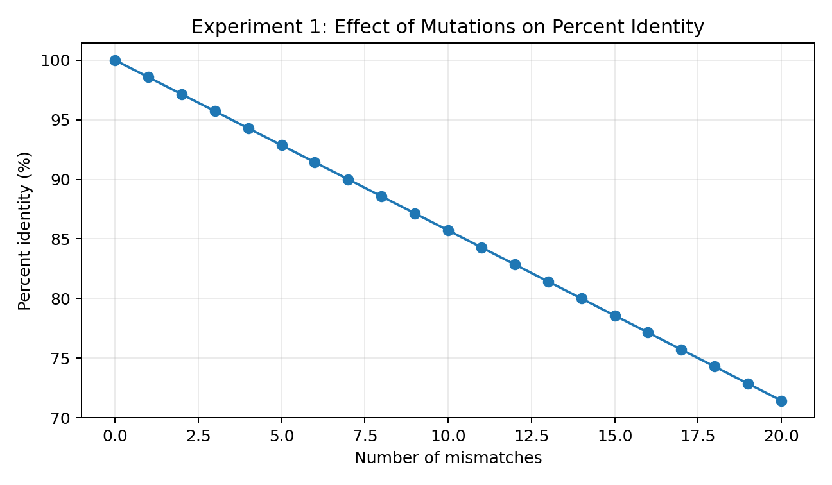
Figure 1. Mutation sensitivity: percent identity decreases as the number of mismatches increases.
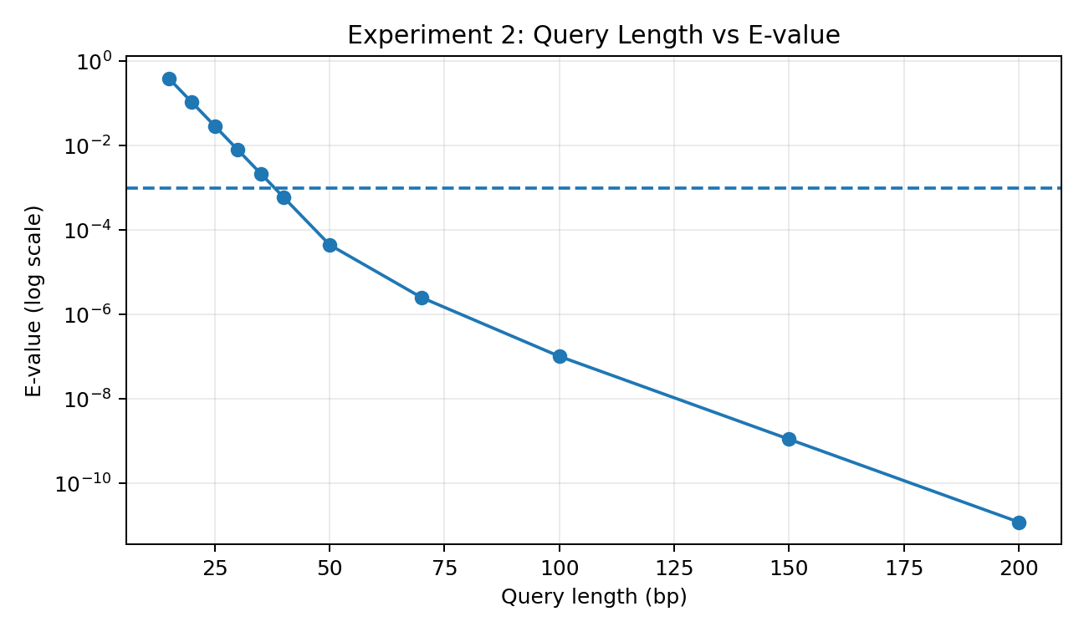
Figure 2. Query length and E-value: longer exact matches produce smaller E-values in this demonstration.
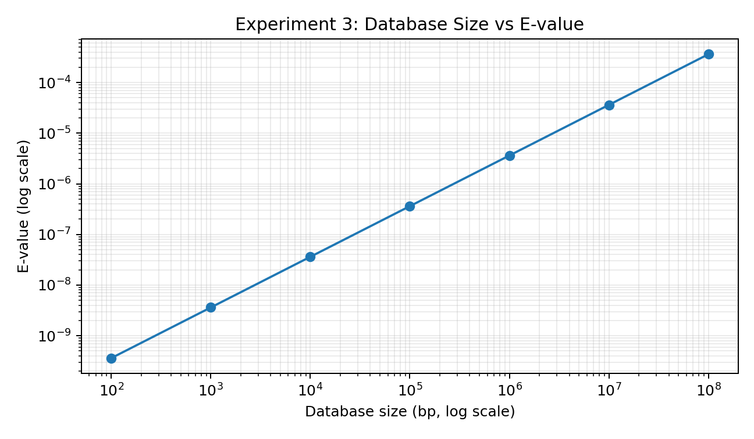
Figure 3. Database size and E-value: for the same score, increasing database size increases the expected number of chance matches.
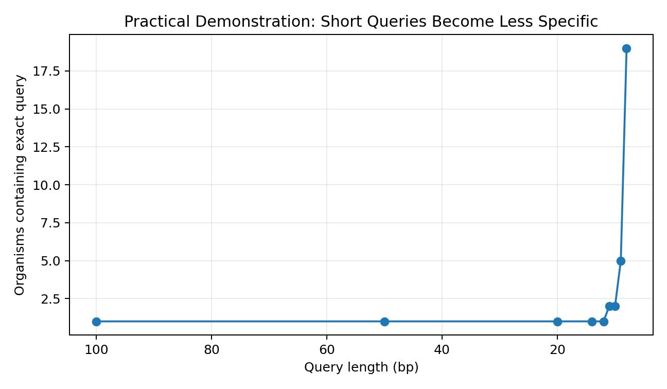
Figure 4. Offline practical demonstration: shorter exact queries occur in more unrelated sequences in the simulated database.

Conclusion

The project combines AI-assisted research, BLAST concepts, Python implementation, controlled experiments and a practical NCBI workflow. The experiments show the effects of mutations, query length and database size on BLAST-like metrics, while the graphical results make these relationships easier to interpret. Together, these components provide both the computational explanation and the practical application of identifying an unknown DNA sequence.

